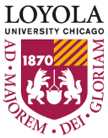
TRiO STUDENT SUPPORT SERVICES

GRADUATE SCHOOL BOOT CAMP

Understanding Personal Values
- Why is it important to have a sense of your values?
- Where do we derive our values from? Are there stories that have influenced the development of particular values in you?
- How does this relate to your intended graduate program/career path?
- Have you ever looked at Loyola’s values? What do you think they are? http://www.luc.edu/mission/mission_vision.shtml\
- Do you consider the values of the institutions you’re applying to graduate school for?
- Do you consider the values of the organizations you’re intending to work for?
- From the list below, can you select your top ten values? Can you select your top 5? Top 2? (adapted from triplecrownleadership.com)
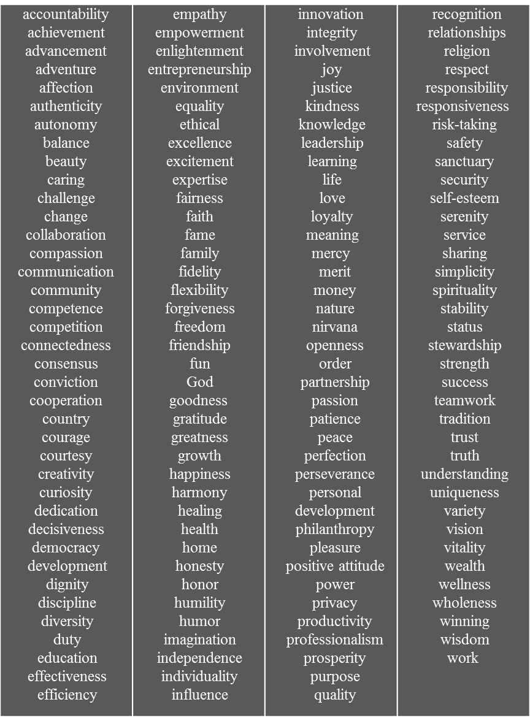
The Graduate School Search
Where to begin?
Choosing a Discipline | Choosing an Institution
- Assess your specific areas of interest and intended career paths and discern why graduate school is imperative to this particular path or your personal growth.  - Conduct Informational interviews with people in this industry regardless of whether they have or have not pursued graduate school. You want to know your industry! Ask to shadow them, ask for advice – use this as a networking opportunity.  - Make a list of your motivations for attending graduate school. Graduate school is FOR YOU – requires a level of motivation and effort far greater than undergrad – go to graduate school when you are PASSIONATE about what you are studying!* | - Program Type: (M.A. vs. M.Ed. vs. Ed.D. vs. Ph.D. vs. J.D. vs. MPP, etc.)*often times, this will impact the length of time it will take to complete the program, as well as requirements for graduation (thesis, comprehensive exams, dissertation, etc.)  - Consider factors of importance to you (location, term system (quarters v. semesters, etc.), graduate assistantship availability, scholarships, program ranking, etc.  - Assess institutional values – are they in line with your own?  - Look at the research interests of the professors in your program. These are future mentors!  - Look at things like career placement or number of graduates that have then pursued a further degree. If looking at PhD programs, look at the number of graduates that have earned a faculty position.

Building a Timeline
- Research Schools and Programs and create a spreadsheet that details the following information:
  - Institution Name
  - Program Name
  - Program Type
  - Location
  - Program Cost
  - Financial Aid availability
  - Application Materials (Personal Statement & any supplemental essays, number of letters of recommendations, admissions test requirements – GRE vs. LSAT vs. MCAT vs. GMAT etc. if applicable, also list what the institution lists as an mean or median score for acceptance)
  - Cost to submit application (this will help you to budget appropriately!)
  - Event dates for prospective students – this will allow you to plan for a visit to the campus. Just like the undergraduate college search, fit is of the utmost importance when searching for a graduate program.
  - Application due date
Personal Statement Writing Tips
*Depth > breadth
**Evaluate experiences (as opposed to simply describing them) **
- “Our approach is very individualized. The way the applicant devises the answer, determines the length, develops the response, is all part of the answer…We can tell when applicants use answers to other schools' questions for our essays; we're sensitive to this.”-Steven DeKrey, Director of Admissions and Financial Aid @ Northwestern University
Questions to ask yourself:
- What's special, unique, distinctive, and/or impressive about you or your life story?
- What details of your life (personal or family problems, history, people or events that have shaped you or influenced your goals) might help the committee better understand you or help set you apart from other applicants?
- When did you become interested in this field and what have you learned about it (and about yourself) that has further stimulated your interest and reinforced your conviction that you are well suited to this field? What insights have you gained?
- Are there any gaps or discrepancies in your academic record that you should explain?
- Have you had to overcome any unusual obstacles or hardships (for example, economic, familial, or physical) in your life?
- What personal characteristics (for example, integrity, compassion, and/or persistence) do you possess that would improve your prospects for success in the field or profession? Is there a way to demonstrate or document that you have these characteristics?
- What skills (for example, leadership, communicative, analytical) do you possess?
Four Step Method:
- Step 1: Do an honest appraisal of your life and passions. Who are you? What do you want out of grad school? Why are you really applying, and why should each of the schools you’re applying to accept you?
- Step 2: Once you have these ideas solidified, think about how you want to present yourself. Even the organization of your personal statement reflects something about yourself, so think about how you want to come off (as authentic to you as possible!).
- Step 3: Just start writing! Remember it will not be perfect on the first (or second, or third…) iteration. Leave yourself enough time to go through multiple drafts and engage outside help (Eliza at your service!).
- Step 4: Edit, edit, edit! Work with me and people you trust to help you make the finishing touches on your personal statement

Tips for Asking for Recommenders to Write Letters of Recommendation
- Pick the right person. Ideally, you will have invested time to form a relationship(s) with the person/people you are asking to be your recommender(s). Letters of recommendation can be a powerful boost (or detriment!) to your application. In order for someone to write an individualized, powerful letter, they need to have had multiple conversations with you.
  - Take interest in your mentors—find people who can talk to you about your passions. This can be a supervisor, professor, or even someone (not related to you) in the same field that you are interested in. Having a mentor relationship allows you to talk with someone in the field and further discern if this is the right field for you. Then, the added benefit is asking for a letter is easier for you and easier for the recommender!
  - The ideal recommender is someone who is able to speak to the qualities the application committee is looking for. For example, if you are applying to medical school, your recommender needs to speak to your empathy, ability to handle difficult coursework, et cetera.
- Give enough notice. You need to give your recommender at least two, more like 3-4 weeks, of notice. This lets your recommender know you appreciate their time and are not forcing them to drop their entire schedule to accommodate you. It also gives the recommender time to think about what he/she will write—meaning a more powerful letter for you. Also, if you give at least that much notice, if something comes up with your recommender you have time to find a replacement. Planning is key!
- Write a letter of request to your recommender(s). This creates a formal request that your recommender(s) can reference in the process of writing your letter.
  - Clearly state what they need to include. Many applications will say explicitly what the letters need to address. If not, give a context (which degree program, at what school, what your goals are, who the letter needs to be addressed to, etc.) for your recommender(s). The more information you give, the easier it is for the recommender. Ease for who you are asking should be one of your top priorities!
  - If the letter needs to be mailed in, include with the letter a pre-addressed and pre-stamped envelope to your institution(s). Again, back to that ease.
  - Clearly state a deadline and in what format. Online deadlines are received immediately, but for physical mail allow more time than necessary for it to be delivered.
    - E.G. If your letters are due in a physical letter by March 1, I would recommend a deadline around February 15. This would mean you’d need to ask for the letter mid-January.
- Remind your recommenders (kindly!). About a week before the deadline you have asked, feel free to reach out to your recommender(s), thank them again, and remind them of the approaching deadline. If they have completed the letter already, they can let you know that.
- Thank your recommenders! This is a commonly forgotten thing. Most people are honored (and expect to be asked, especially in educational settings) to be asked to be a recommender. Yet, consider that these people took time out of their schedules to vouch for you towards a dream you have articulated.
  - A minimum thank you is a handwritten note delivered/sent to each recommender.

Interviewing With Graduate School Programs
Depending on the type of program you are pursuing, you may be asked to interview with faculty and/or staff from the program. For example, almost all PhD Programs and MD Programs will require several levels of interviews. Many MBA Programs and JD Programs will also require an interview. If you are pursuing an assistantship, research position, or fellowship with the program you’re pursuing, you’ll most likely need to interview to vie for one of these coveted spots, as they generally offer financial assistance.
An interview will allow for you to bring your application materials to life. Know your resume, know your personal statement, and be able to clearly communicate your motivations for pursuing the intended program. The Loyola University Chicago Career Center identifies “ten personal themes for the job interview” that can be perfectly tailored to the graduate school interview search. (Their interview guide can be found here: http://www.luc.edu/media/lucedu/career/pdfs/interviewing.pdf) You can always schedule a mock interview with ACE Staff or with the Career Center if you feel you want more practice. The guide has been modified for this process here:
Develop Your Personal Themes for the Program/School Interview
1. Passion for the Work: “Why am I interested in working in this field/in this industry?” Why do you feel a passion for the discipline/institution? Give specific examples of the things that excite you.
2. Motivation and Purpose: Interviewers will want to know why you want to seek their particular graduate program. Ask yourself, “Why do I want this interview?” Don’t simply repeat your resume and employment history. What’s the most compelling case you can make to prove your interest?
3. Skills and Experience: Consider your key skills and how they’ll serve you in this program. Avoid clichés and generalities; instead, offer specific evidence. Think about your weaknesses and how you can minimize and balance them with your strengths. Try to describe yourself as objectively as possible.
4. Diligence and Professionalism: Describe your professional character, including thoroughness, diligence, and accountability. Give proof that you persevere to see important projects through, and that you achieve desired results. Demonstrate how you handle challenges.
5. Creativity and Leadership: Offer evidence of your effectiveness, including creativity, initiative, resourcefulness, and leadership. What examples can you provide for each? Focus on how you overcome problems; take advantage of opportunities that might otherwise be overlooked, and foster cooperation to gain the support of others to accomplish goals.
6. Compatibility with the Program/Institution: Discuss how this program and the institution espouse values and interests in line with your own.
7. Personality and Cultural Compatibility: Consider your personality within your cohort and with the faculty. How do you fit in with other types of personalities? What types of people would enjoy working with you for hours at a time? Your goal is to develop responses that make the interviewers feel confident that you fit the type of candidate they are seeking.
8. Problem-Solving Ability: Offer proof, with examples, of your problem-solving ability. How have you resolved difficult issues in the past? Focus on real issues, on logical value-added solutions, on practical outcomes of your work, and on realistic measures of judging these outcomes. What are problems in your identified industry that you’re passionate in learning more about/solving?
9. Accomplishments: Think about your initiative and accomplishments. Offer examples in which you’ve delivered more than what was expected. Is your program more academic or practical? This might influence the accomplishment(s) that you choose to highlight.
10. Career Aspirations: Above all, show why you are passionate about the program that you’re pursuing and how this graduate degree will compliment your intended career path.
*Just as with the letters of recommendation, it is always important to send a thank you letter/e-mail no later than 24 hours after the interview.*

